Lab Task 11

Q No :1

import os
with open ('file.txt','r') as myfile:
var = 0
for row in myfile:
print (row)

import csv
with open ('file.txt','r') as myfile:
with open('file1.csv','w+') as f:
writer = csv.writer(f)
for row in myfile:
writer.writerow([row[0],row[2],row[1],int(row[0]) + int(row [1]) + int(row[2])])
f.seek(0)
for r in f:
print r

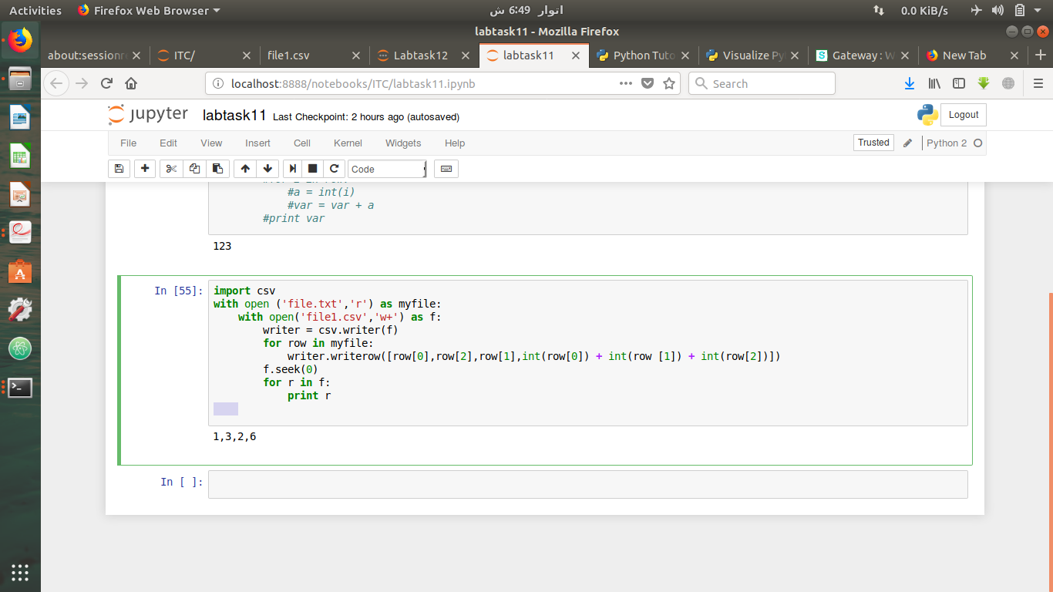

Q No2:
with open('airpot.csv','r') as plane:
reader = csv.reader(plane)
for i in reader:
if (i[3] == "Australia") or (i[3] == "Russia"):
print i[3],"=",i[1]
else:
continue

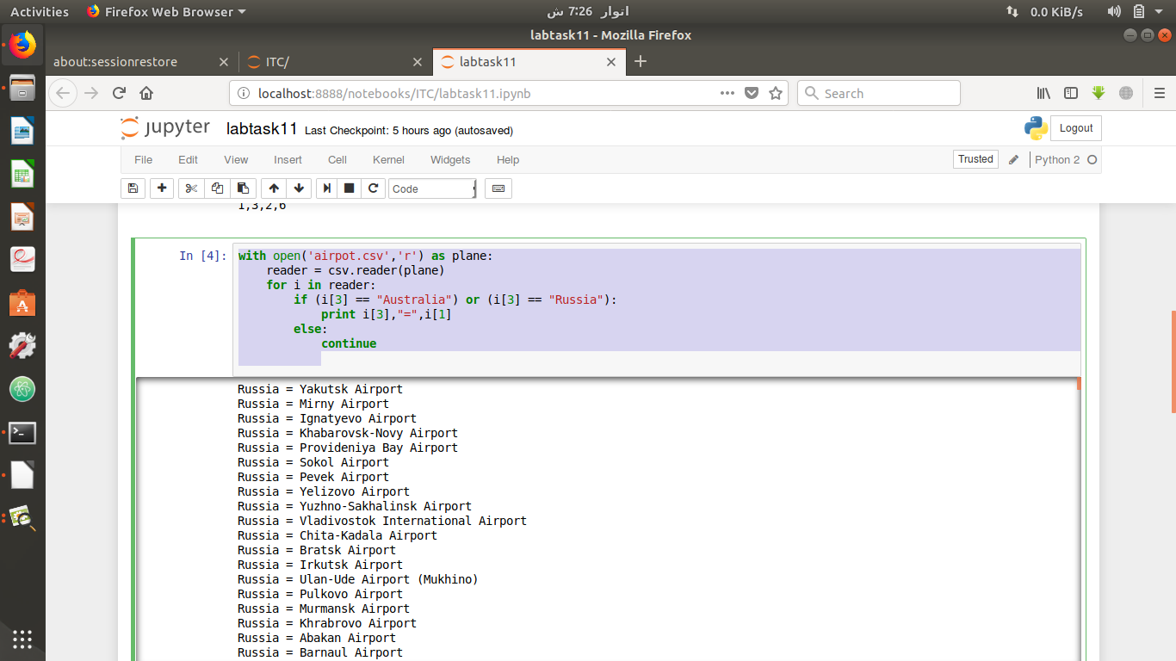

with open('airpot.csv','r') as plane:
reader = csv.reader(plane)
for i in reader:
if (i[3] == "Australia") or (i[3] == "Russia"):
print i[3],"=",i[1]
else:
continue

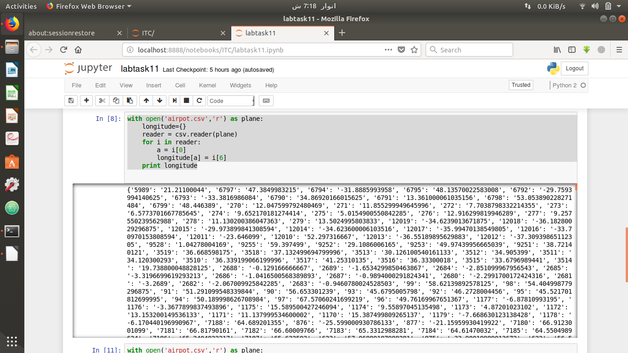

with open('airpot.csv','r') as plane:
altitude={}
reader = csv.reader(plane)
for k in reader:
b = k[0]
altitude[b] = k[7]
print altitude

